STUDY GUIDE
United Nations Development Programme (UNDP)
TOPIC B: Reevaluation of Sustainable Development Goals (SDG’s) with special emphasis on achieving targets in Less Economically Developed Countries
BACKGROUND:
In June 2012, representatives of 192 countries met in Rio at the UN conference on Sustainable Development to launch a government led process for creating a set of universal sustainable development goals. The countries adopted a set of goals to end poverty, protect the planet and ensure prosperity for all as part of a new development agenda.
In September 2015, world leaders gathered in New York to agree on a new development plan; “Agenda 2030 for Sustainable Development”, including the 17 Goals. The newly adopted SDGs reflect a coherent, holistic, comprehensive and balanced framework incorporating the three dimensions of sustainable development: social, economic and environmental with recognition of the direct linkages between human well-being, economic development and a healthy environment. The SDGs aim to end poverty in all its forms, and promote healthy lives and wellbeing for all; end hunger for all; and ensure availability and sustainable management of water and energy for all. The six essential elements of SDGs provide conceptual guidance towards achieving all the SDGs. These elements are dignity, people, prosperity, our planet, justice and partnership.
On January 1st 2016, the 17 Sustainable Development Goals (SDGs) of the 2030 Agenda adopted by world leaders in September 2015 at the historic UN Summit officially came into force. Over the next fifteen years, with these new Goals that universally apply to all, countries will mobilize efforts to end all forms of poverty, fight inequalities and tackle climate change, while ensuring that no one is left behind.
The 2030 Agenda offers the opportunity to correct the errors and omissions of the ‘MDG(Millennium Development Goals) approach’, an approach that has reduced the development discourse to a focus on the symptoms of extreme poverty and the provision of basic social services in poor countries. While without doubt these issues are extremely important, the MDGs approach failed to adequately address the structural flaws of the global economic and financial systems, the imperative of ecological sustainability and the responsibilities of the global North.
CURRENT SITUATION
The 2030 Agenda offers the opportunity to respond in an integrated manner to urgent global problems, such as accelerating global warming and growing inequalities. It recognizes that ending poverty must go hand-in-hand with strategies that build economic growth and address a range of social needs including education, health, social protection and job opportunities, while tackling climate change and protecting the environment.
The Sustainable Development Goals (SDGs) contained in the 2030 Agenda incorporate a commitment to reduce inequalities within and among countries, a clear demand for sustainable consumption and production patterns and the aspiration for peace, fair governance and justice. The 2030 Agenda is universal, not just because the SDGs are global in scope, but also because all the countries have to do something to achieve them. No country can deem itself to be sustainably developed and having already done its part to meet the SDGs. The 2030 Agenda offers the opportunity to challenge the idea that development is a phenomenon that occurs only in countries of the global South while the North is already ‘developed’.
While the SDGs are not legally binding, governments are expected to take ownership and establish national frameworks for the achievement of the 17 Goals. Countries have the primary responsibility for follow-up and review of the progress made in implementing the Goals, which will require quality, accessible and timely data collection. Regional follow-up and review will be based on national-level analyses and contribute to follow-up and review at the global level.
WHAT IS SUSTAINABLE DEVELOPMENT?
According to the UN, sustainable development is defined as :“Development that meets the needs of the present without compromising the ability of future generations to meet their own needs.”
Sustainable development implies economic growth together with the protection of environmental quality, both reinforcing the other. The essence of this form of development is a stable relationship between human activities and the natural world, which does not diminish the prospects for future generations to enjoy a quality of life at least as good as our own.
For sustainable development to be achieved, it is crucial to harmonize three core elements: economic growth, social inclusion and environmental protection. These elements are interconnected and all are crucial for the well-being of individuals and societies.
Eradicating poverty in all its forms and dimensions is an indispensable requirement for sustainable development. To this end, there must be promotion of sustainable, inclusive and equitable economic growth, creating greater opportunities for all, reducing inequalities, raising basic standards of living, fostering equitable social development and inclusion, and promoting integrated and sustainable management of natural resources and ecosystems.
WHAT DO SUSTAINABLE DEVELOPMENT GOALS COVER?
The 17 goals SDGs cover 5 main themes which are
People:
To end poverty and hunger, in all their forms and dimensions, and to ensure that all human beings can fulfill their potential in dignity and equality and in a healthy environment.
Prosperity:
To ensure that all human beings can enjoy prosperous and fulfilling lives and that economic, social and technological progress occurs in harmony with nature.
Partnership:
To mobilize the means required to implement this agenda through a revitalized Global partnership for SD, based on a spirit of strengthened global solidarity, with the participation of all countries, all stake holders and all people.
Peace:
To foster peaceful, just and inclusive societies which are free from fear and violence. There can be no development without peace and no peace without sustainable development.
Planet:
To protect the planet from degradation through sustainable consumption and production, sustainably managing its natural resources and taking urgent action on climate change, so that it can support the needs of the present and future generations.
HOW ARE SUSTAINABLE DEVELOPMENT GOALS MONITORED?
At the global level, the 17 Sustainable Development Goals (SDGs) and 169 targets of the new agenda are being monitored and reviewed using a set of global indicators. The global indicator framework is being developed by the Inter Agency and Expert Group on SDG Indicators (IAEA-SDGs), that were agreed on by the UN Statistical Commission in March 2016. The Economic and Social Council and the General Assembly have now adopted these indicators. Individual Governments are developing their own national indicators to assist in monitoring progress made on the goals and targets, while Chief statisticians from Member States are working on the identification of the targets with the aim to have 2 indicators for each target. There will be approximately 300 indicators for all the targets. Where the targets cover cross-cutting issues, however, the number of indicators may be reduced. The means of implementation of the SDGs will be monitored and reviewed as outlined in the Addis Ababa Action Agenda, the outcome document of the Third International Conference on Financing for Development, to ensure that financial resources are effectively mobilized to support the new sustainable development agenda. The follow-up and review process will be informed by an annual SDG Progress Report prepared by the Secretary-General.
HOW ARE SDGs DIFFERENT FROM MILLENIUM DEVELOPMENT GOALS?
17 Sustainable development goals with the 169 goals go further than the MDG’s by addressing the root causes of poverty and the universal need for development that works for all people. The goals cover the three dimensions of sustainable development: economic growth, social inclusion and environmental protection. They build on the success and momentum achieved by MDGs in last 15 years and the SDGs intend to finish the job to get to a statistical ‘zero’ on hunger, poverty, preventable child deaths and other targets. Millennium development goals allowed countries to ‘do the easiest parts’ first. Getting to zero requires a real focus on empowering the poorest and hardest to reach. MDGs were created by a group of people in a basement of UN headquarters but The SDGs were created in one of the most inclusive processes the world has ever seen, with face to face consultations in more than 100 countries and thorough input of million of citizens from all over the world.
17 GOALS:
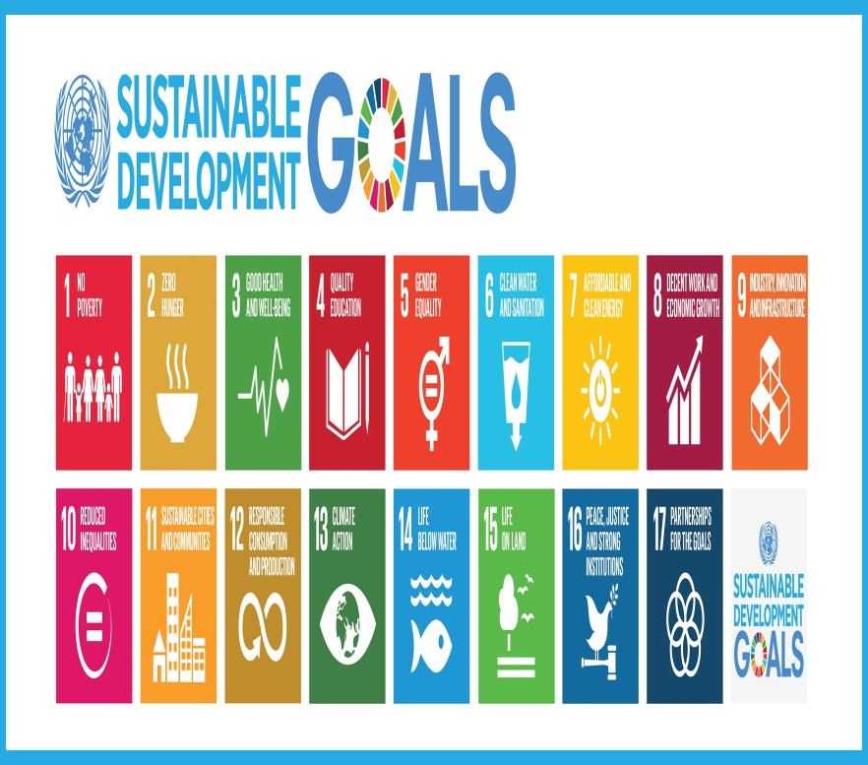
Goal 1: End poverty in all its forms everywhere
Extreme poverty rates have been cut by more than half since 1990. While this is a remarkable achievement, one in five people in developing regions still live on less than $1.25 a day, and there are millions of others who make little more than this daily amount, plus many people are in the risk of slipping back into poverty.

Goal 2: End hunger, achieve food security and improved nutrition and promote sustainable agriculture
It is time to rethink how we grow, share and consume our food. If done right, agriculture, forestry and fisheries can provide nutritious food for all and generate decent incomes, while supporting people-centered rural development and protecting the environment. A profound change of the global food and agriculture system is needed if we are to nourish today’s 795 million hungry and the additional 2 billion people expected by 2050.
Goal 3: Ensure healthy lives and promote well-being for all at all ages
Ensuring healthy lives and promoting the well-being for all at all ages is essential to sustainable development. Significant strides have been made in increasing life expectancy and reducing some of the common killers associated with child and maternal mortality. Major progress has been made in increasing access to clean water and sanitation, reducing malaria, tuberculosis, polio and the spread of HIV/AIDS. However, many more efforts are needed to fully eradicate a wide range of diseases and address many different persistent and emerging health issues.
Goal 4: Ensure inclusive and quality education for all and promote lifelong learning Obtaining a quality education is the foundation for improving people’s lives and sustainable development. Major progress has been made towards increasing access to education at all levels and increasing enrolment rates in schools particularly for women and girls. Basic literacy skills have improved tremendously, yet bolder efforts are needed to make even greater strides for achieving universal education goals. For example, the world has achieved equality in primary education between girls and boys, but few countries have achieved that target at all levels of education.
Goal 5: Achieve gender equality and empower all women and girls
Gender equality is not only a fundamental human right, but a necessary foundation for a peaceful, prosperous and sustainable world. Providing women and girls with equal access to education, health care, decent work, and representation in political and economic decision-making processes will fuel sustainable economies and benefit societies and humanity at large
Goal 6: Ensure access to water and sanitation for all
Clean, accessible water for all is an essential part of the world we want to live in. There is sufficient fresh water on the planet to achieve this. But due to bad economics or poor infrastructure, every year millions of people, most of them children, die from diseases associated with inadequate water supply, sanitation and hygiene.
Goal 7: Ensure access to affordable, reliable, sustainable and modern energy for all
Energy is central to nearly every major challenge and opportunity the world faces today. Be it for jobs, security, climate change, food production or increasing incomes, access to energy for all is essential.
Goal 8: Promote inclusive and sustainable economic growth, employment and decent work for all
Roughly half of the world’s population still lives on the equivalent of about US$2 a day. And in many places having a job doesn’t guarantee the ability to escape from poverty. This slow and uneven progress requires us to rethink and retool our economic and social policies aimed at eradicating poverty.
Goal 9: Build resilient infrastructure, promote sustainable industrialization and foster innovation
Investments in infrastructure – transport, irrigation, energy and information and communication technology – are crucial to achieving sustainable development and empowering communities in many countries. It has long been recognized that growth in productivity and incomes, and improvements in health and education require investment in infrastructure.
Goal 10: Reduce inequality within and among countries
The international community has made significant strides towards lifting people out of poverty. The most vulnerable nations – the least developed countries, the landlocked developing countries and the small island developing states – continue to make inroads into poverty reduction. However, inequality still persists and large disparities remain in access to health and education services and other assets.
Goal 11: Make cities inclusive, safe, resilient and sustainable
The challenges cities face can be overcome in ways that allow them to continue to thrive and grow, while improving use of resources and reducing pollution and poverty. The future we want include cities of opportunities for all, with access to basic services, energy, housing, transportation and more.
Goal 12: Ensure sustainable consumption and production patterns
Sustainable consumption and production aims at “doing more and better with less,” increasing net welfare gains from economic activities by reducing resource use, degradation and pollution along the whole lifecycle while increasing quality of life. It involves different stakeholders, including businessmen, consumers, policy makers, researchers, scientists, retailers, media personnel and development cooperation agencies, amongst others.
Goal 13: Take urgent action to combat climate change and its impacts
People are experiencing the significant impacts of climate change, which include changing weather patterns, rising sea levels, and more extreme weather events. The greenhouse gas emissions from human activities are driving climate change and continue to rise. They are now at their highest levels in history. Without action, the world’s average surface temperature is projected to rise over the 21st century and is likely to surpass 3 degrees Celsius this century with some areas of the world expected to warm up even more. The poorest and most vulnerable people are the most affected by climate change.
Goal 14: Conserve and sustainably use the oceans, seas and marine resources
Our rainwater, drinking water, weather, climate, coastlines, much of our food, and even the oxygen in the air we breathe, are all ultimately provided and regulated by the sea. Throughout history, oceans and seas have been vital conduits for trade and transportation.
Goal 15: Sustainably manage forests, combat desertification, halt and reverse land degradation, halt biodiversity loss
Deforestation and desertification caused by human activities and climate change – pose major challenges to sustainable development and have affected the lives and livelihoods of millions of people in the fight against poverty. Efforts are being made to manage forests and combat desertification.
Goal 16: Promote just, peaceful and inclusive societies
Goal 16 of the Sustainable Development Goals is dedicated to the promotion of peaceful and inclusive societies for sustainable development, the provision of access to justice for all, and building effective, accountable institutions at all levels.
Goal 17: Revitalize the global partnership for sustainable development
A successful sustainable development agenda requires partnerships between governments, the private sector and civil society. These inclusive partnerships built upon principles and values, a shared vision, and shared goals that place people and the planet at the centre, are needed at the global, regional, national and local level.
POINTS TO BE COVERED
- Critique of individual goals in context of Lesser Developed Countries
- Comparative Analysis and reasons for failure of the MDGs
- Possibility and feasibility of global collaboration
READING MATERIAL:
- http://www.un.org/sustainabledevelopment/sustainable-development-goals/
- http://www.undp.org/content/undp/en/home/sustainable-development-goals.html
- http://www.lead.org.pk/lead/attachments/SDGFlyer_english.pdf
- http://unsdsn.org/wp-content/uploads/2015/12/151211-getting-started-guide-FINAL-PDF-.pdf
- http://www.slovakaid.sk/sites/default/files/sdgs_booklet_web_en.pdf

